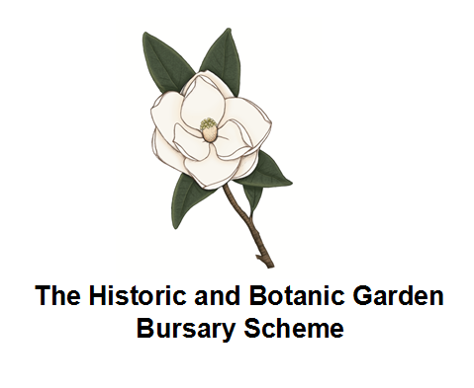

HBGTP Trainee Exit Questionnaire
Trainee name:
Host garden:
Period of placement:

The Scheme

- How did you find the application process?

- Regarding support from the scheme: Would you have liked more contact, less or was this just right?

- Did the scheme add significantly to:
  - your understanding of horticultural industry?

  - your body of practical skills?

  - your plant knowledge?

- What did you like about the scheme?

- What changes would you like to see made to the scheme?

- What additional elements could the scheme offer for the benefit of the trainees?

The Placement

- Was the placement as you had expected?

- What was the best aspect of your placement?

- Did your Supervisor meet your needs under the scheme?

- Did your colleagues support you in your efforts?

- Did you consider that the resources of the garden accommodated the diversity of tasks that you would have liked to undertake?

- Did you experience a variety of machinery?

- Did you have adequate access to a computer and an email account?

- Did you work on a variety of sites in the garden?

- Did you feel too much time was spent on mundane tasks and not enough on training?

- Were the health and safety aspects of the site and your tasks, a cause for concern at any time during your placement?

The future

- What are your plans for your immediate future?

- What are your long-term objectives?

- Have these changed as a consequence of your involvement with the scheme?

- What future involvement can you envisage with the scheme?

- Other comments:

Please complete and return to the Scheme Administrator, Anna Jacka. Email to: anna.jacka@english-heritage.org.uk, or post to: English Heritage, Wrest Park, Silsoe, Bedfordshire, MK45 4HR.

