TRAINEE DIARY - OCTOBER

Monday 23rd October 2006 – Week One, Day One!

Early rain cleared to blue sky and sunshine!

Met by David and taken through garden to the glasshouses to join Graham who was painting the benches to protect them against weathering. Previous attempt to strip and paint with wood stain only lasted 18 months hence switch to undercoat and overcoat (Conker) with 1-2 coats of each layer. At Kevock earlier this autumn we used ‘Timprotec’ an oil based wood stain which was comparatively expensive at £29 a 5L can with 2 coats required; whereas this undercoat was only £7 and the top coat £11.99.

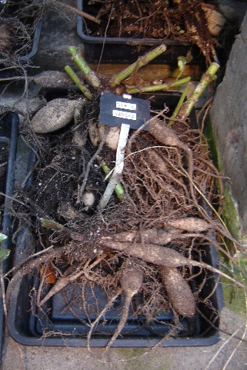
Walk around with Jim May (Property Manager/Head Gardener) both outside and inside the walled garden. Lots of background information to put the garden in historical context from 1750 to 1976 when acquired by NTS; and up to present day. He has also written a paper entitled ‘Reflections on Greenbank’, covering his period in the garden.

Other activities in the garden
Canna were lifted from the raised beds and potted up by the volunteers for storage in the polytunnel.

Dhalia were also lifted, shaken free from soil and left to dry off on trays on floor in the glasshouse (see Dhalia ‘Sandra’, right). Normally this would have been done much earlier, possibly even at end Sept but very mild autumn – still no frosts. Decision to lift to ensure time for bulbs to begin establishing roots. Later discovered that at RHS Wisley they drill holes in the Dhalia tubers to help drain out the fluid.

Plants of interest
Callicarpa bodinerii var. giraldii ‘Profusion’ - superb purple berries (see Plant Profiles)
Bergenia ‘Helen Dillon’ Jim says it is the best Bergenia for autumn colour and good for small gardens as it has a smaller leaf.

Miscellaneous
Ken Cox is writing a book about hardy plants for Scotland and appears to be involved in the launch of ‘Scottish Plant Award’ to highlight plants which are suitable for Scottish gardens.

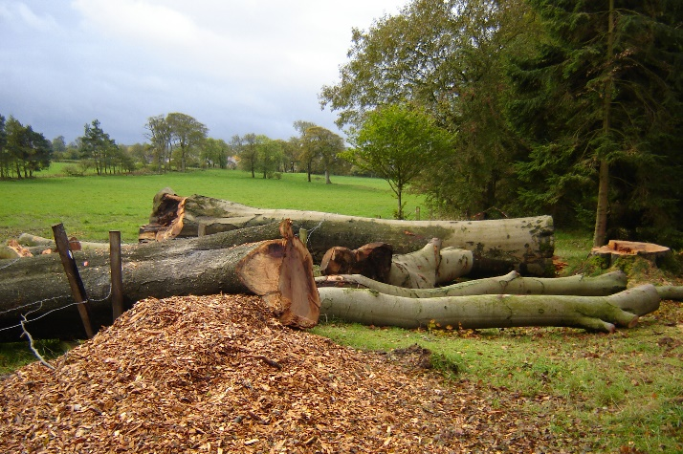
Records of planting in the garden and other horticulturally relevant information were lost when the Hamiltons sold the property in 1962 to Mr Blythe and the old ‘retainer’ burnt all the family papers – only a map from 1772 was salvaged.

During the previous week 9 large, mature and dangerous trees had been felled by an external contractor (none actually inside the walled garden). This included 2 very large beech trees in the field outside the front door. Wood was/is either chipped for use by the garden or taken away as logs for timber/firewood. Most of the trees had suffered internal rot from forked trunks.

Tuesday, 24th October 2006

Overcast but dry

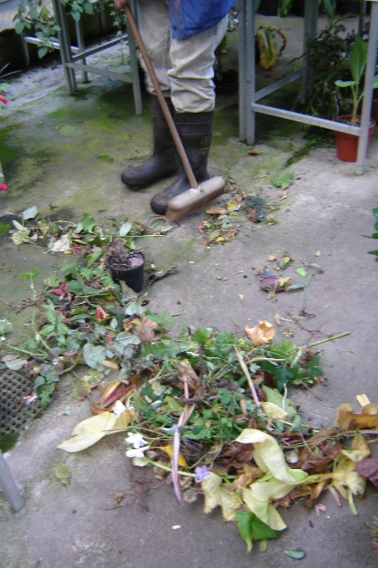
Removed dead and diseased plant material in the glasshouses with Graham (see right). Plants packed on the bench with some suffering because of lack of space and mixing habitat types (Greenbank has largest collection of Cacti in NTS). Money is available from the Friends of Greenbank (FOG) to help finance new glasshouse but has to be combined with re-location of garden service facilities from courtyard which would allow courtyard to be developed with improved café and shop etc. Delayed due to absence of appropriate surveyor.

Arranged and planted daffodil bulbs with Graham in the raised beds in the disabled garden near potting shed. Bulbs were taken from the unsold bulbs from the Bulb Fair organised on behalf of FOG and would be regarded as a donation. Bulbs laid out in rows with gap between to help identification of varieties when lifted after flowering. I opted for a chevron pattern in the middle bed – David had already allocated the bulbs to beds.

Lifted bedding plants in the Sensory Garden, mostly Pelargonium, which were heaped in the service area awaiting the return of the shredder from servicing. After shredding, material will be left to rot down and will be reapplied as compost this time next year. Area was weeded, forked over and given a mulch of well rotted garden compost which was lightly forked in. Area was then replanted with prepared Hyacinthus bulbs.

Spent afternoon being introduced to the computer by David and completing more of the ‘Induction’ with Jim.

Other activities
Contractor continued to process the felled trees and remove material for logging.

Plants of interest
Zinnia had been grown from seed as part of the Gardening Which? (GW) trial of late sown hardy annuals.
Narcissus – there are over 300 different varieties, many dating from the 1920s when Major Hamilton had a passion for them and would acquire expensive bulbs from top breeders.

Miscellaneous
There is a problem with un-named varieties within the garden (including Paeonia, Narcissus, Galanthus…). Phlox came from a Clyde Valley breeder who subsequently stopped growing them as in his mind they were overshadowed by later breeding programmes.

Wednesday, 25th October 2006
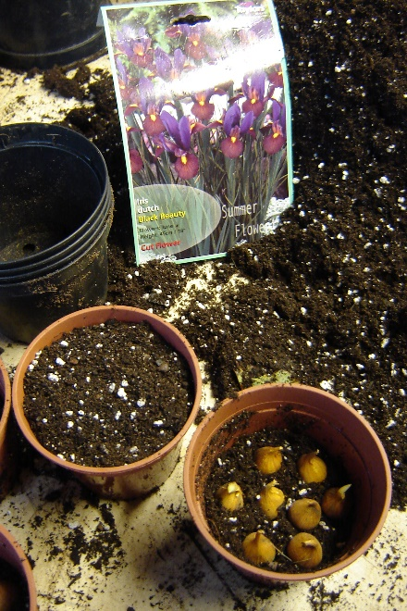
Heavy rain overnight, morning overcast, light rain in the afternoon.

Tidied in glasshouse.

Potted up surplus bulbs from the Bulb Fair (see right) for plunging in gravel beds in the disabled garden beside the potting shed for spring display. The tarmac paths in this area are the remains of a tennis court. The surrounding beds are at different heights to allow easier access. Gravel is for field drainage as cheaper. Display included pots of bulbs from previous years.

We also potted daffodils and some tulips for plunging in gravel beds along the edge of the glasshouse (approx 5 per 2L). During the summer these display areas are plunged with tender plants from the glasshouse.

Cleared annuals and weeds from the winter/spring garden as part of autumn tidy. Helped create a 3 foot circle of Ajuga reptans around Prunus ‘Snow Storm’. Worked with Graham and Des who trimmed the grass edges.
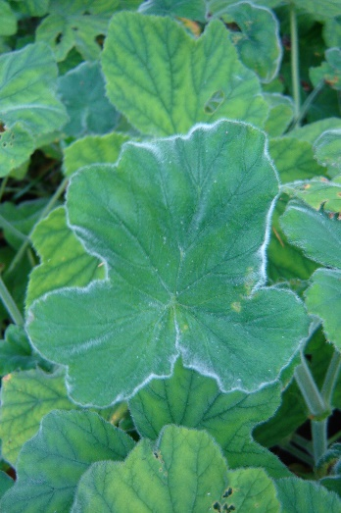
Other activities
Volunteer Des cleared leaves and fallen apples in the autumn garden.
Volunteer Tom cut back herbaceous material in the summer garden.
Volunteer ladies tidied the parterre (they bring their own flasks etc and just arrive about 1200 get on with a job and leave about 1600).
Contractors continued to remove fallen timber.

Plants of interest
Pelargonium tomentosum (see right) wonderful foliage in the summer garden even if showing signs of chlorosis. Lovely texture like velvet. Common name is peppermint scented geranium.

Miscellaneous
‘Terravent’ is a relatively new machine for blasting air down one metre into lawns to revitalise them.

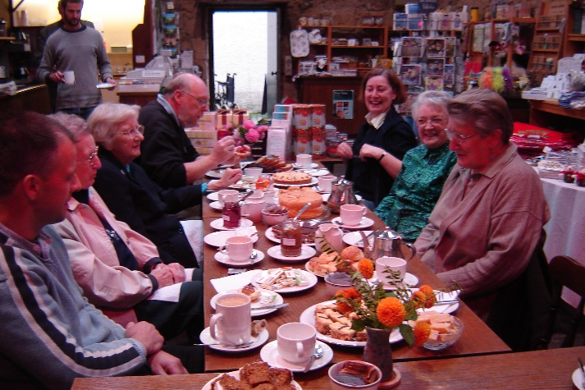
GW has several different trials running at Greenbank. In return, Greenbank are paid and provided with the plants and allowed to dispose of them as they wish. A recent trial looked at tender plants and how they might survive a Scottish winter (ironically one of the mildest winters for several years!) – only survivors were Trachycarpus fortunei and Dicksonia antartica (whose only winter protection was frosted fern foliage used to tuck up the new growth i.e. no polythene sheets or straw). Ex-Delphinium trial plants were given to NTS Haddo as it has better soil (early planted plants generally flowered themselves to death; late planted ones formed good clumps and would have flowered well in their second year).

Shared the ‘thank you tea’ provided by Sandra for all the volunteers who have helped in the shop over the season. A magnificent spread, including jams, all homemade by her (see right).

Thursday, 26th October 2006
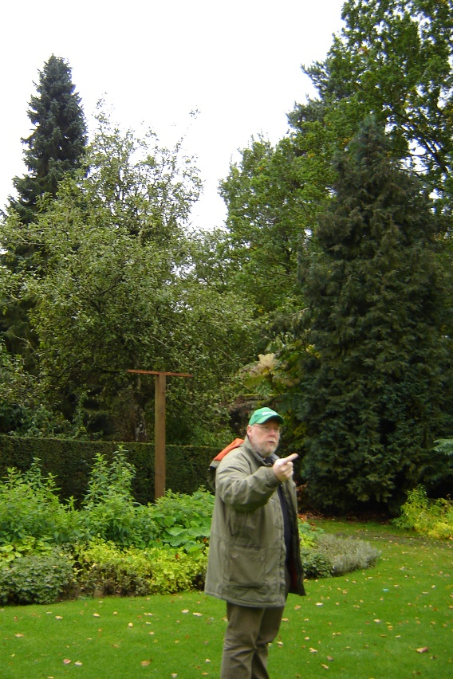
Heavy rain in the morning but lifted during the afternoon.

Tidied plants in the glasshouse with David.

Walk and explanation with David in summer garden (see right). Annual borders behind him will be dug in, once the plants have been hit by frost. The ‘gallows’ are for summer hanging baskets.

He also mentioned that the main winter projects would be the ripping out of the Fuchsia border and ripping out the failed cherry in the summer garden (possibly also the conifers behind him). It will then be replaced with a bird ‘block of flats’, similar to those used by doves (not sure if wild birds will appreciate living so close together).

Plants of interest
Gallardia ‘Butter & Marmalade’
Sorbaria (with golden leaf)
Holcus mollis (Fog grass) lovely white & green stripes but very weedy.
Cotinus ‘Young Lady’
Clematis ‘Crystal Fountain’ – supposed to be climbing up the declining plum tree.
Erysium ‘Stars & Stripes’
Erysium ‘Apricot Surprise’

Miscellaneous
Due to the persistent threat of vandalism, any interpretation in garden must be cheap, disposable and easily replaceable.

Bird boxes were moved in spring 2006, but do not seem to have been utilised by the birds – seem very close together and also only 6 feet away from the door into the potting shed.

A problem in the garden is how to fill the gaps left by the spring bulbs.

Anemone blanda needs soaking in warm water before sowing (should ideally be for 48hrs in tepid water).

Friday, 27th October 2006

Overcast, mainly dry but some light showers; lots of leaves fell during the night. Extremely windy over night.

Cleaned through the glasshouse.

Potted up bulbs for sale (prepared Hyacinthus; Allium karataviense; Galanthus ‘Floreo Pleno’).

Lifted Abutilon pictum ‘Thompsonii’ from the winter garden where they were used as summer bedding on top of the winter/spring bulbs. They were over 6ft high, but were cut down to about 2-3ft, re-potted and placed in the glasshouse for the winter.

Plants of interest
Sandra mentioned Decaisnea insignis which she had bought from RBGE, but it had produced purple pods not golden (as species name would suggest)!

Tuesday, 31st October 2006 - Week Two

Very windy overnight, but calm at Greenbank

Briefly opened up and tidied glasshouse.

Rest of day spent at Culzean with David, Graham and other NTS staff learning about HAVS (Hand Arm Vibration Syndrome) – very sobering, particularly the personal accounts of both Ian Stephenson (First Gardener – Level 2) and Ian Cornelius (Head Forrester – Level 3). HAVS is a disease which affects circulatory, nervous and musculoskeletal systems. It is caused by excessive contact with vibrating tools, particularly in cold and damp conditions. The HAVS levels 1-4 are an industry wide scale. Symptoms include: numbness; tingling; white finger; reduced hand sensation and dexterity. Level 4 looked very like bad frostbite and generally results in amputations.

Under new NTS guidelines (in line with The Control of Vibration at Work Regulations, 2005 and HSE publications), all staff will be tested for symptoms and will have to complete monitoring forms recording use of vibrating machinery (max 400 points per week). All individual pieces of equipment are to be regularly tested (summer and winter) as ratings will vary according to age and levels of maintenance (this different to the NT which has adopted generic approach). If equipment has not been tested it can be given a temporary rating at double the manufacturer’s guidelines. All equipment should be signed ‘in’ and ‘out’.
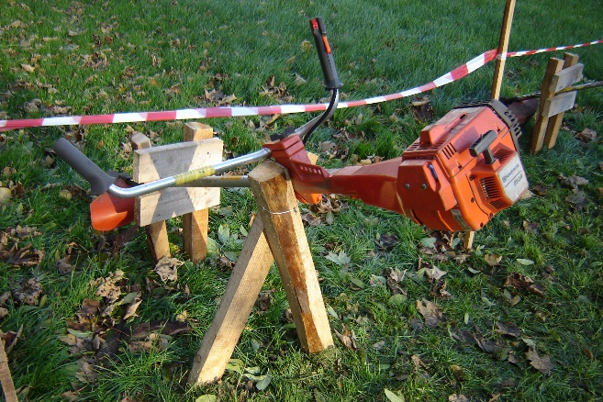

We were given useful handouts and allowed to sample levels of vibration on different power tools, including a strimmer, which was secured in a wooden support for H&S and to prevent theft as it was beside the public car park (see right) and a quadbike.

Handouts attached.

